It is a popular framework persisting/saving java objects in database. It is built on top of JDBC and takes away all the low-level work.

ORM- Object to relational mapping.

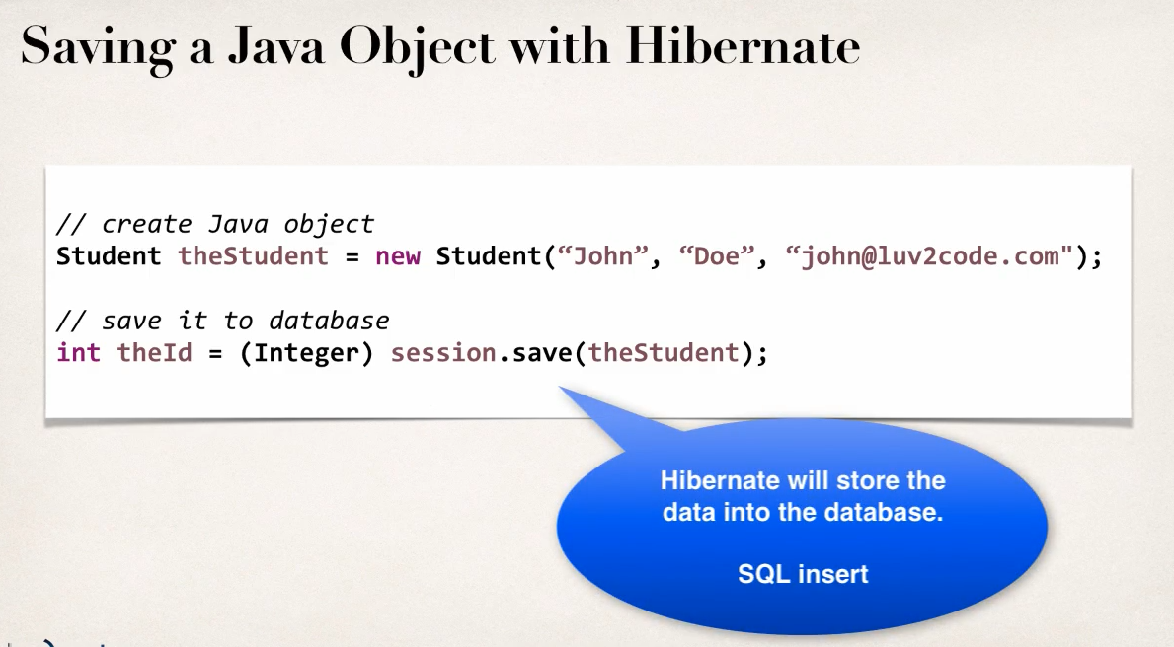

(As always stupid installation process, bunch of memorizations of library needed. easier to use spring boot or just download the jar files).

From the Hibernate ORM >lib we only add the required jar files in our module. And then we need the MySQL/j connector which includes the JDBC drivers as well.

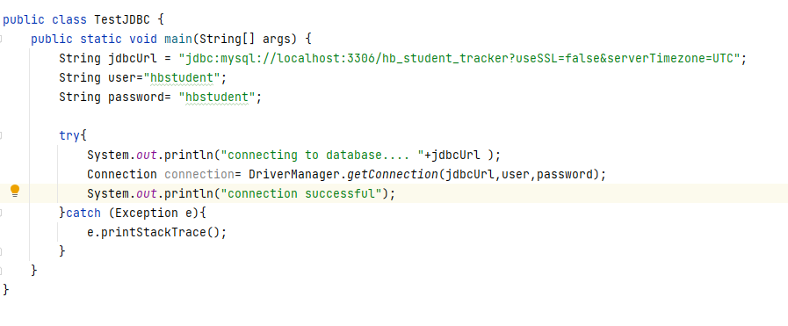

Core java implementation in the above picture.

**Configuration:** Next step is to configure the hibernate configuration file. This is very similar to .env file in node express. Get the template from internet of the config file and define properties there.

**Entity class:** A fancy annotation for a java class that is mapped a database table. There are two options for configuring the entity class, xml config file (legacy, won’t use this) and java annotations(suggested).



If class name is same as table, the **@Table** annotation name is optional, but it’s preferred to avoid confusion.

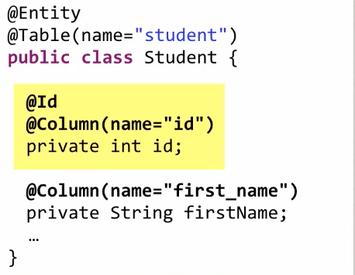 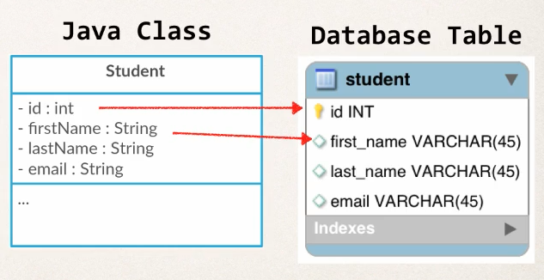

The **@Id** annotation means it will be used as primary id. We will use **javax.persistence** import for these.

**Saving an object (Create part of the CRUD):**

* **SessionFactory:** This is a heavy-weight object we only create once in an application. This reads the config files and creates session objects.
* **Session:** Short lived objects that’s wraps a JDBC connection with database. This object we use to save/retrieve objects form database. This is retrieved from SessionFactory.

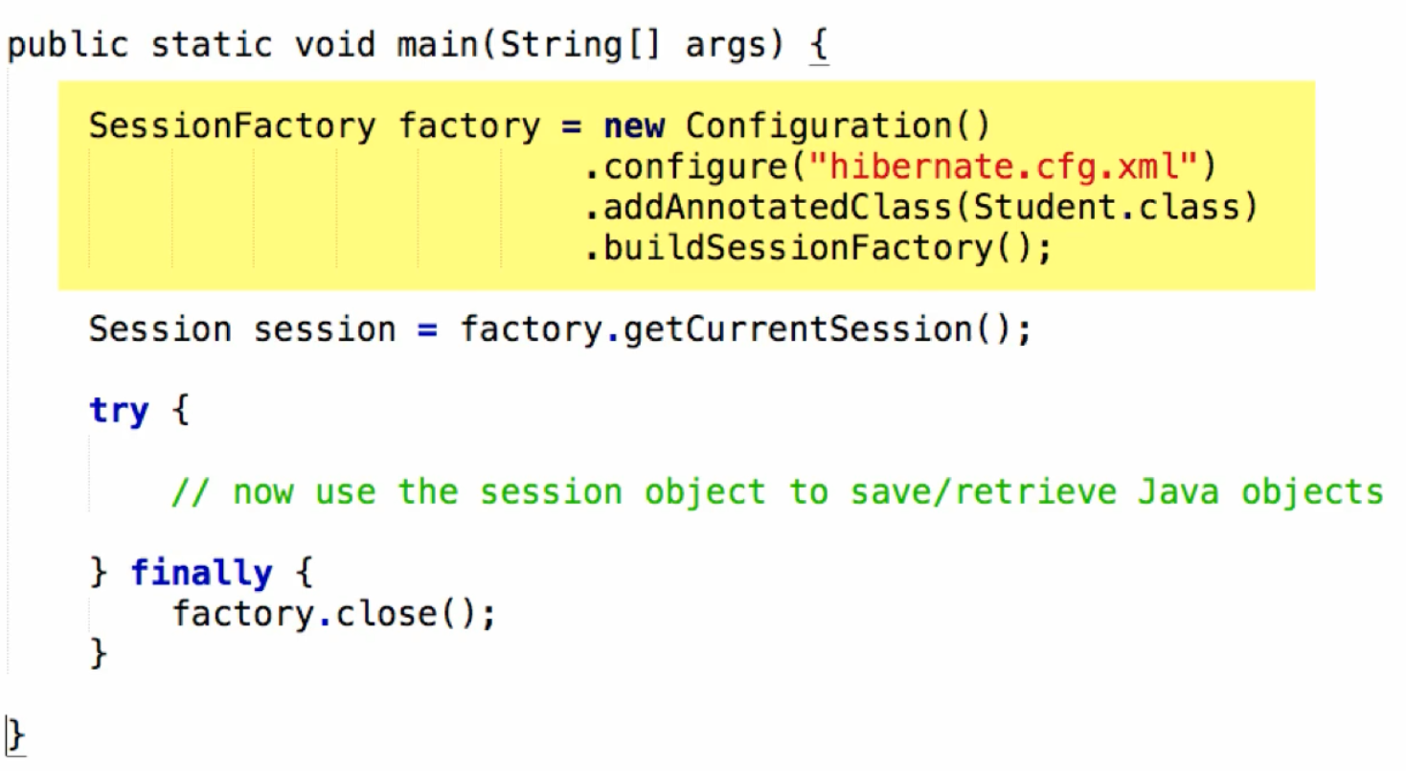

**Note:** If no configuration file name is specified in the .configure method, it will look for this default file name, that is hibernate.cfg.xml.

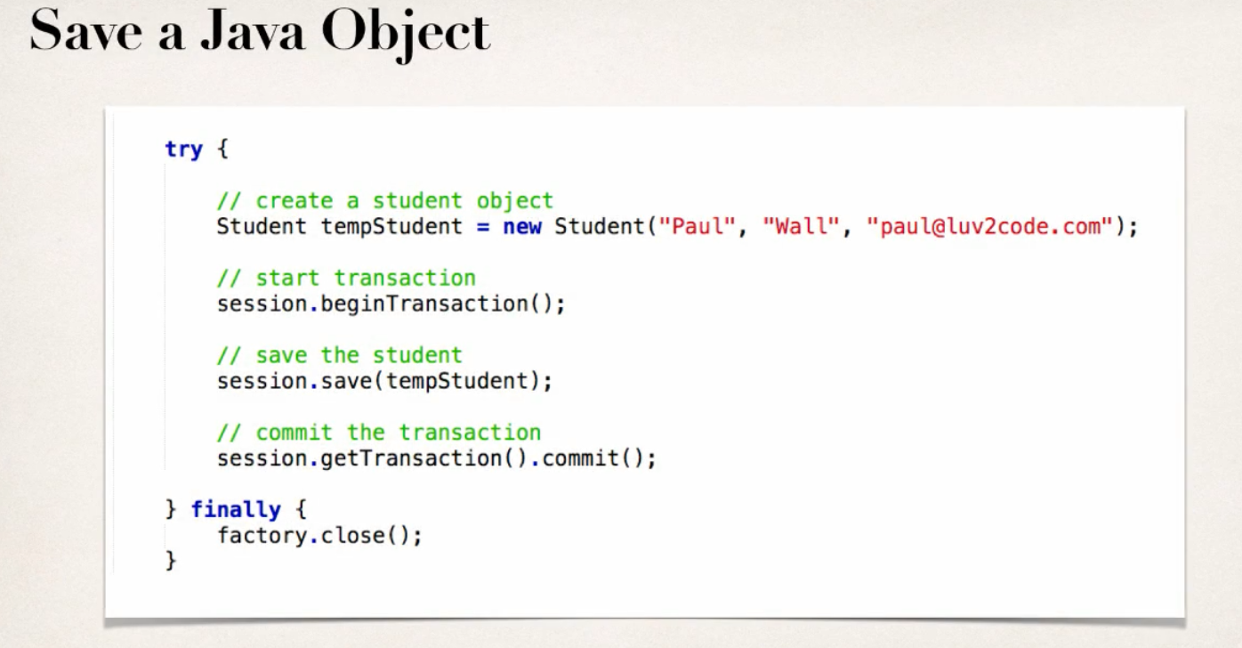

**Note**: The process is very similar to how I worked in **mongoose**, you have to actually commit the transaction to save it in database.

**Primary Key:** Unique value, can’t be null and used to uniquely identify each row of the table.

* If nothing is specified, hibernate will generate key automatically
* if we want to specify it there is @GeneratedValue attribute. The most commonly used one is **GenerationType.IDENTITY.**

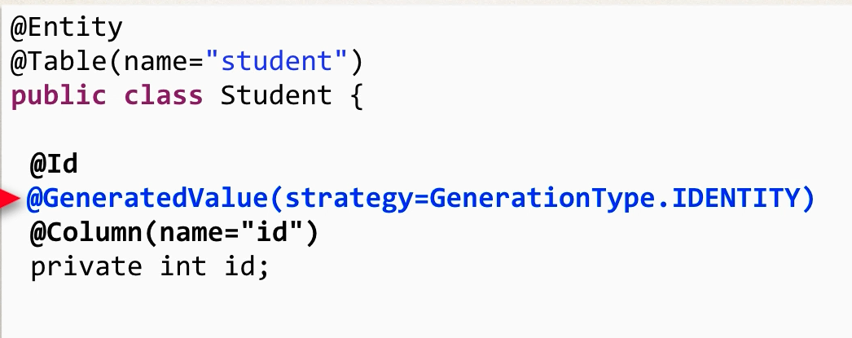

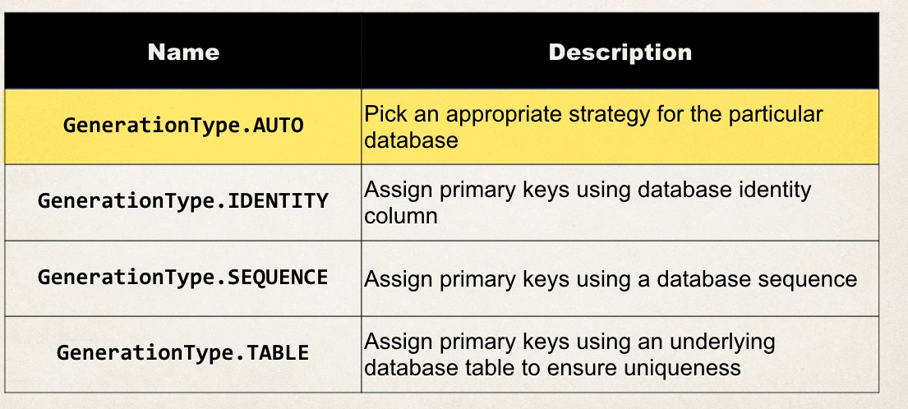

* In case we want to code our key generation, there is option too.

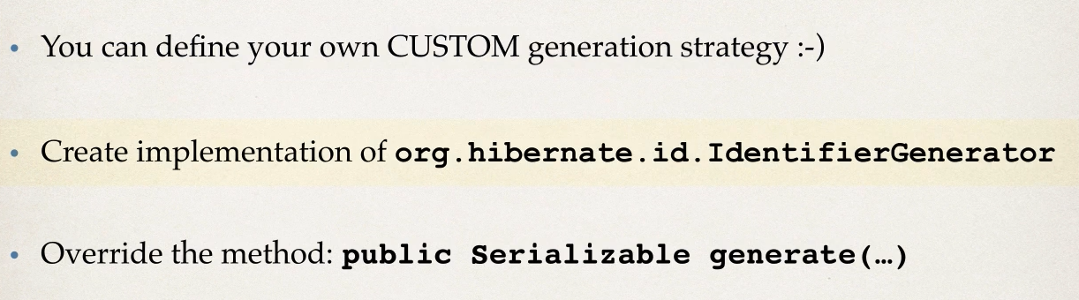

We can specify auto increment id as well, google for code.

**Reading an object (Read part of CRUD):**

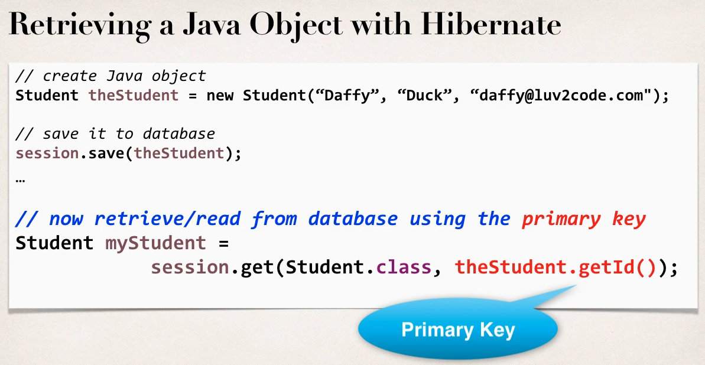

If not found, it returns null.

**Hybernet Query Language (HQL):**

Similar to LinQ in C#.

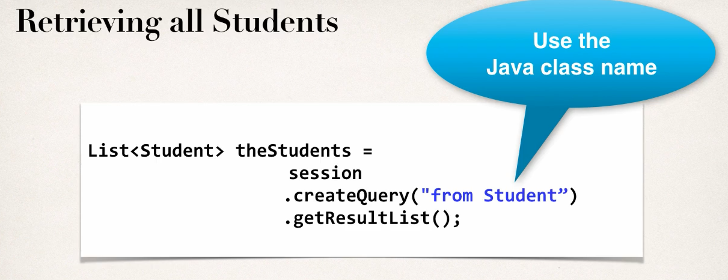 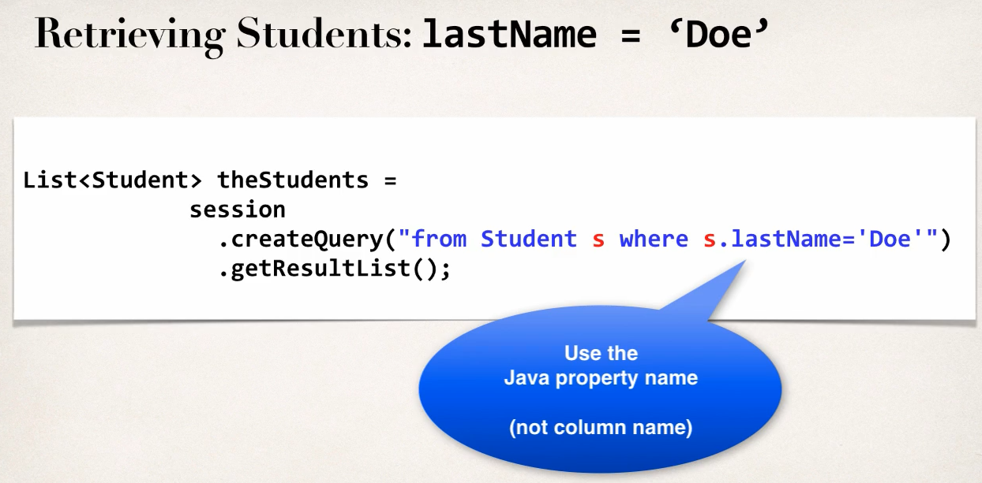

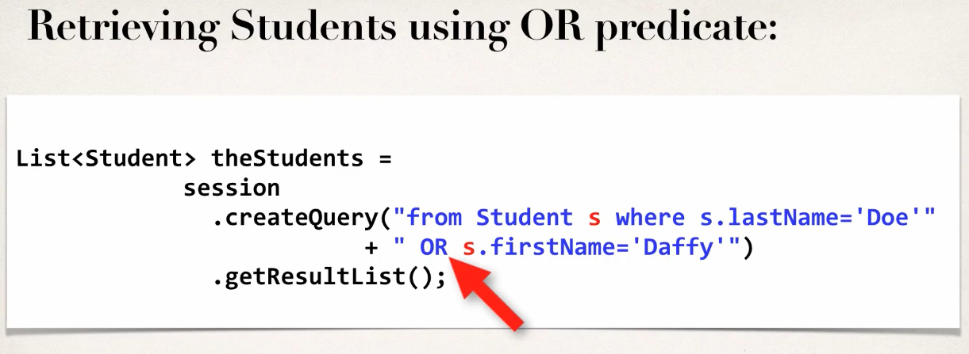 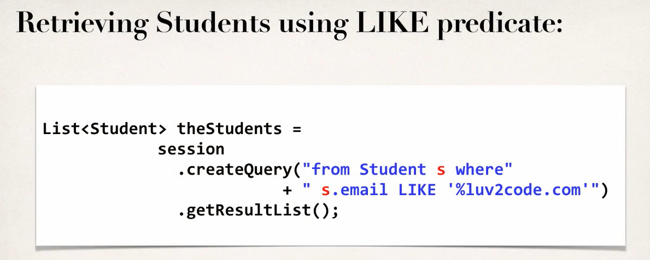

**Updating an Object (Update of CRUD)**

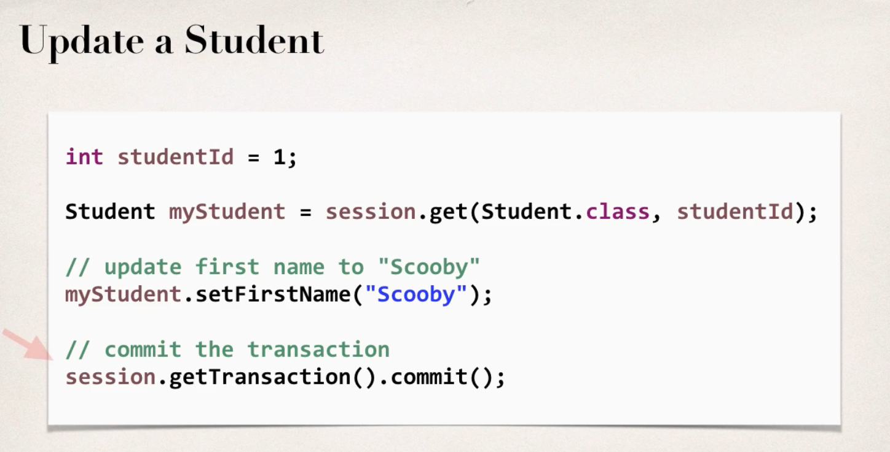 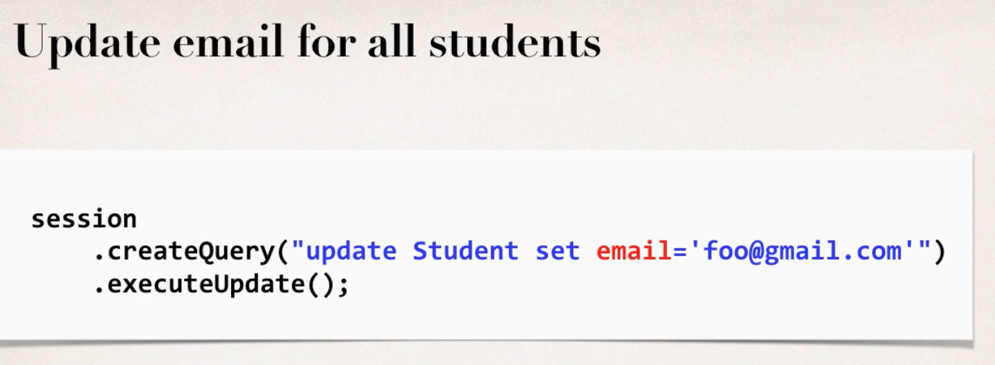

**Deleting an object (Delete of CRUD)**

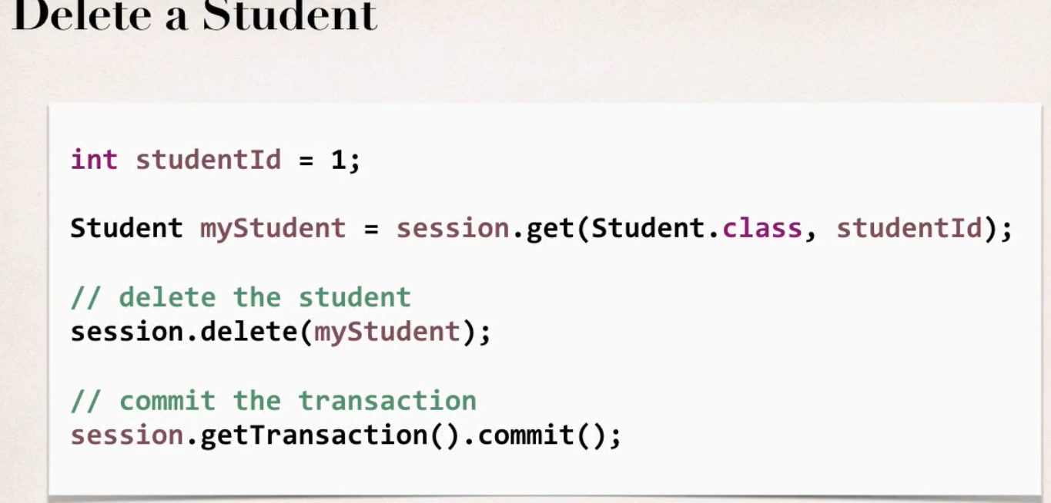 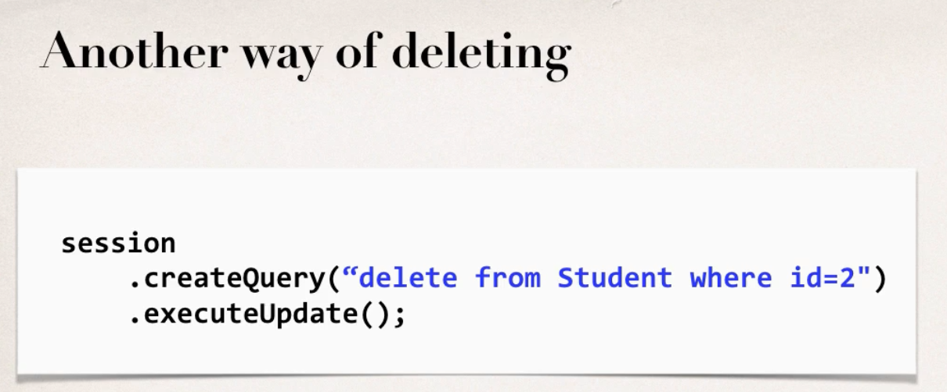

**Modeling the database:** There usually more than one table and usually relationship between tables as well.

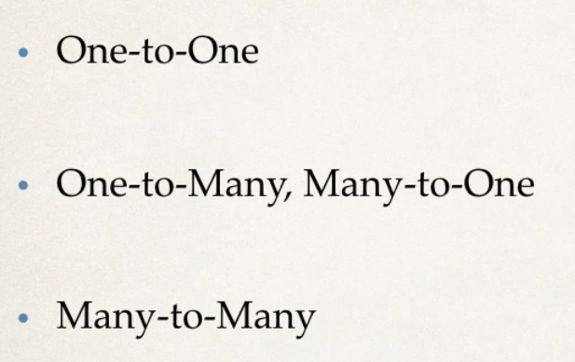

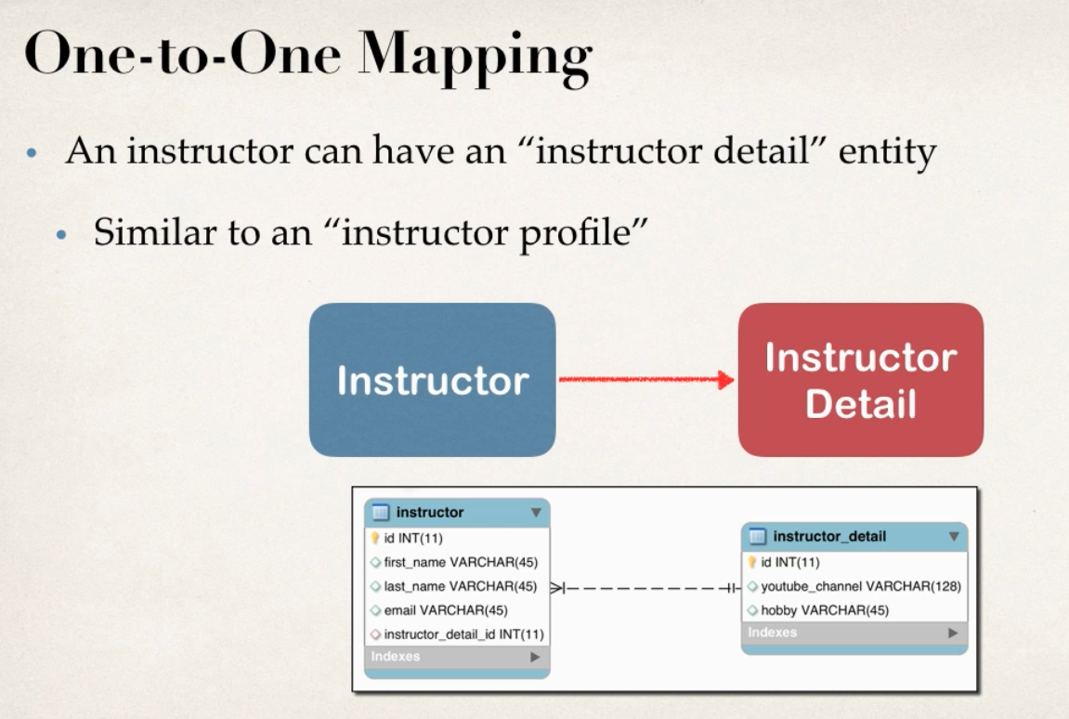 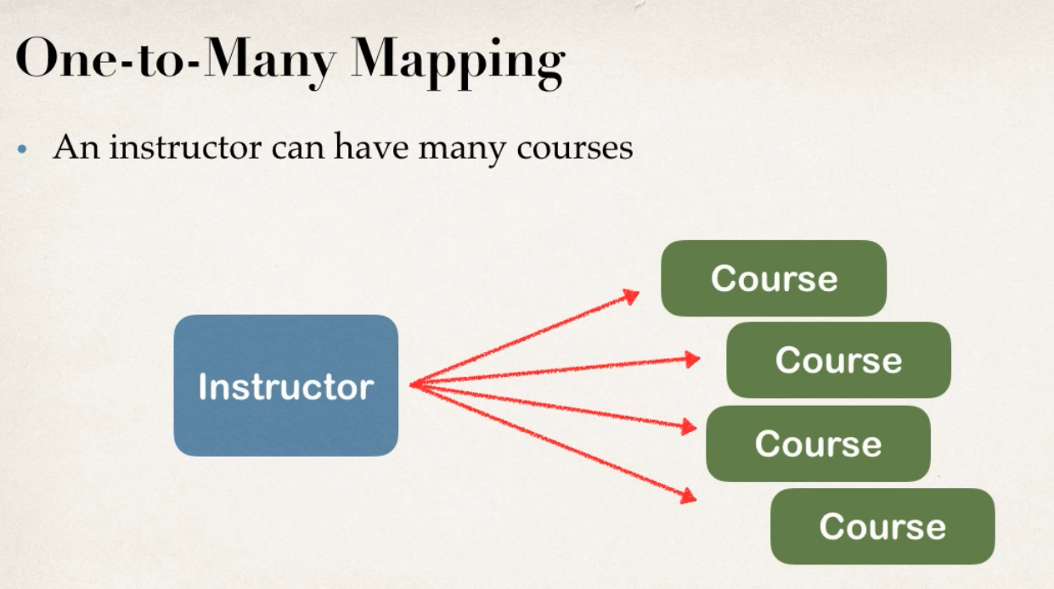

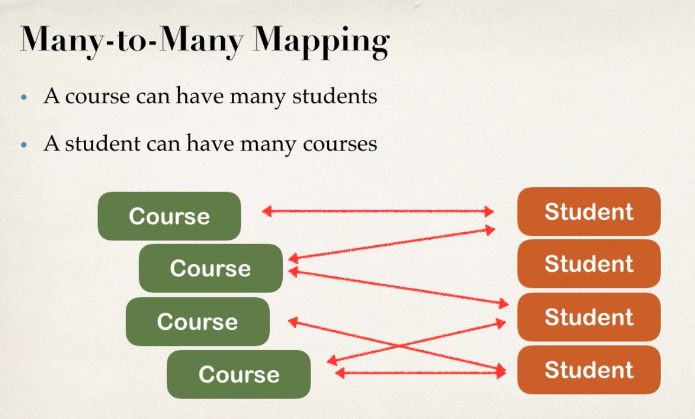

**Primary and Foreign key: …………**

**Cascade:** This means we can apply same operation to related entities. So for example, in the first picture, if we save the instructor table it will cascade and save instructor details as well.

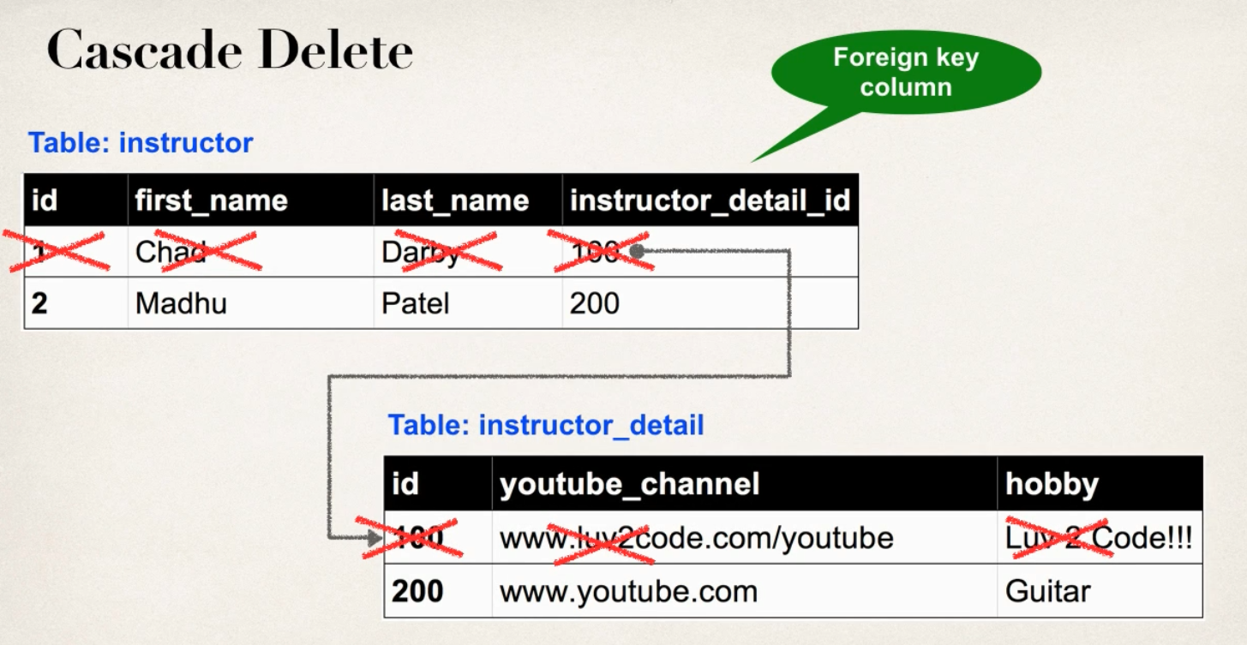

But this cascade delete is a bit complex, in case of many-to-many operations deleting would mess up things. We can configure the cascading as a developer.

**Eager / Lazy Loading:** We can configure this as well, if we want eager or lazy loading of data.



**Uni/Bi Directional relationship:**

